1. **Agenda**:
   1. We will discuss the Challenge# 4 that we may face in developing Microservice or Cloud-Native App.
2. **Challenge**: The configuration management inside the Microservice.
3. 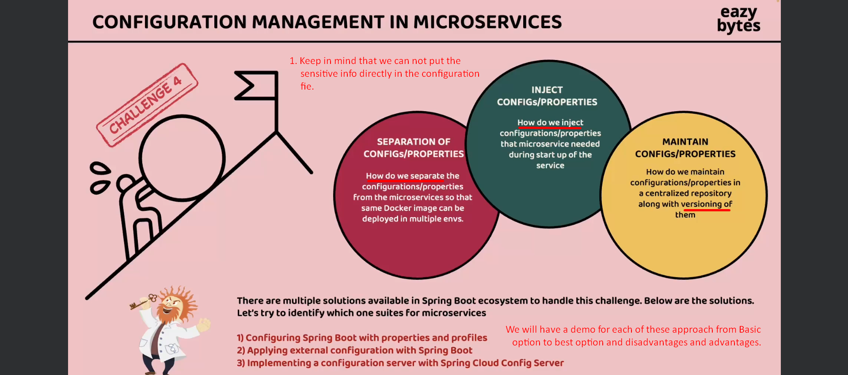
4. 